# A comprehensive framework to capture the arcana of neuroimaging analysis

Thomas G. Close1,2, Phillip G. D. Ward1,3,4, Francesco Sforazzini1, Wojtek Goscinski6, Zhaolin Chen1,5, Gary F. Egan1,3,4

1. Monash Biomedical Imaging, Monash University, Melbourne, Australia

2. Australian National Imaging Facility, Australia

3. Australian Research Council Centre of Excellence for integrative Brain Function, Melbourne, Australia

4. Monash Institute of Cognitive and Clinical Neurosciences, Monash University, Melbourne, Australia.

5. Department of Electrical and Computer Systems Engineering, Monash University, Melbourne, Australia

6. Monash eResearch Centre, Monash University, Melbourne, Australia

# Introduction

Despite the availability of well-established neuroimaging analysis packages (Cox 1996; Smith et. al. 2004; Friston et. al. 2007; Tournier et. al. 2012), the arcana of neuroimaging analysis is substantial due to the range of available tools, tunable parameters, and imaging sequences involved (Cusack et. al. 2015). The distribution of complete “end-to-end” workflows, from acquired data to publication results, is necessary for routine reproduction because of the effort required to accurately exactly reimplement such analyses (Kennedy 2018). It is also difficult to adapt existing workflows to new studies without detailed knowledge of their design. Therefore, flexible, portable and complete workflows are important to promote reproduction and code reuse in neuroimaging research.

A barrier to designing portable and complete workflows is the heterogeneity of data storage conventions (Marcus et. al. 2007; Das et. al. 2011; Gorgolewski et. al. 2016). To address this, the emerging Brain Imaging Data Standard (BIDS) (Gorgolewski et. al. 2016) provides a way to standardise the storage of neuroimaging data in file system directories. BIDS specifies strict file and directory naming conventions, which facilitate the design of portable *BIDS Apps* (https://bids-apps.neuroimaging.io). However, for research groups with sufficient informatics support, software-managed repositories (Marcus et. al. 2007; Das et. al. 2011) can provide additional features, such as flexible access-control and automated pipelines. Therefore, for published workflows, the choice of repository should be transparent in order to maximise their audience.

While neuroimaging analyses are generally amenable to standardisation (Kennedy 2018), minor modifications are often required to accommodate idiosyncrasies of the acquisition protocols in use at different sites (Esteban et al. 2018). Therefore, workflows may require conditional logic in construction or execution to be portable. Nipype is a flexible Python framework for neuroimaging analysis in which workflows are constructed programmatically in Python (Gorgolewski et al. 2011). Programmatic construction allows for rich control-flow logic that is not readily available in alternative workflow frameworks (Cusack et. al. 2015; Achterberg et. al. 2016; Amstutz et. al. 2016), and has been used to implement workflows that are robust to differences in fMRI protocols across a large number of sites (Esteban et al. 2018).

The trend towards large multi-site and multi-contrast datasets collected over a number of years (Van Essen et. al. 2012; Thompson et. al. 2014; Sudlow et. al. 2015) presents additional challenges to workflow design. Analysis packages are constantly being developed and improved, so the state-of-the-art workflow for a particular analysis can change over time. Therefore, it is challenging to ensure workflows are applied consistently over the course of long studies (Cusack et. al. 2015).

While analysis workflows for different contrasts and modalities are typically implemented independently, they can share common processing steps (e.g. non-linear registration to standard space, surface parcellation) and their outputs may need to be integrated to produce publication results. For large scale studies, which are typically processed on the cloud or high-performance computing (HPC) clusters, rerunning common segments can lead to significant increases in computation time and therefore project cost. In addition, duplication of processing segments increases time for manual quality control (QC), making the reuse of intermediate derivatives a practical requirement for some large studies (Schreiber et. al. 2018).

To maximise the reusability of neuroimaging workflows and avoid frequent reimplementation of standard analyses, workflow implementations should be flexible, extensible and applicable to a wide range of storage systems. In addition, in order to promote routine reproduction of neuroimaging studies, published workflow implementations should include the complete procedure, from acquired data to publication results. However, ensuring workflow implementations are flexible, portable and complete adds a high degree of complexity and effort to the design process.

Our objective was to extract common elements of repository-centric workflow design into an abstract framework to make it practical to implement flexible, portable and complete workflows for a wide range of neuroimaging analyses. *Abstraction of Repository-Centric ANAlysis (Arcana)* (http://arcana.readthedocs.io)is a Python framework for designing complex workflows in which modular Nipype pipelines operate on data stored in various repositories. Intermediate derivatives are derived on demand, checking against stored provenance for required updates. Analyses can be applied to XNAT, BIDS and plain-directory repositories, and using Nipype’s execution plugins, run on workstations or be submitted as batch jobs to HPC schedulers. Arcana’s architecture, with programmatic workflow construction—yet clear delineation between analysis design and application—facilitates the implementation of complex workflows that are portable and complete.

The utility of the Arcana framework is demonstrated by the implementation of analysis suites for T1, T2* and diffusion weighted MRI (dMRI) data and the application of dMRI tractogram (Tournier 2012) and composite vein image (Ward 2018) workflows to data collected from a healthy subject.

# Methods

## Framework overview

The separation of analysis design and application in the Arcana framework follows the conceptual divide between classes and objects in Object-Oriented (OO) software design. *Study* classes encapsulate imaging data with the suite of analysis methods that can be performed on them, and, in the basic case, are specialised for a specific imaging contrast or modality. Study objects apply the analysis suite defined in the Study class to a specific dataset.

The set of acquired data, the derivatives that can be derived from it, and methods that construct pipelines to derive the derivatives, are linked together by the *data specification* *table* of the Study class (Figure 1). Likewise, free parameters used in pipeline construction are defined in the class’ *parameter specification* *table*. Class inheritance can be used to specialise analysis suites by overriding pipeline constructor methods or entries in the specification tables. Analysis suites for multi-modal data can be implemented by combining multiple Study classes in *MultiStudy* classes*.*

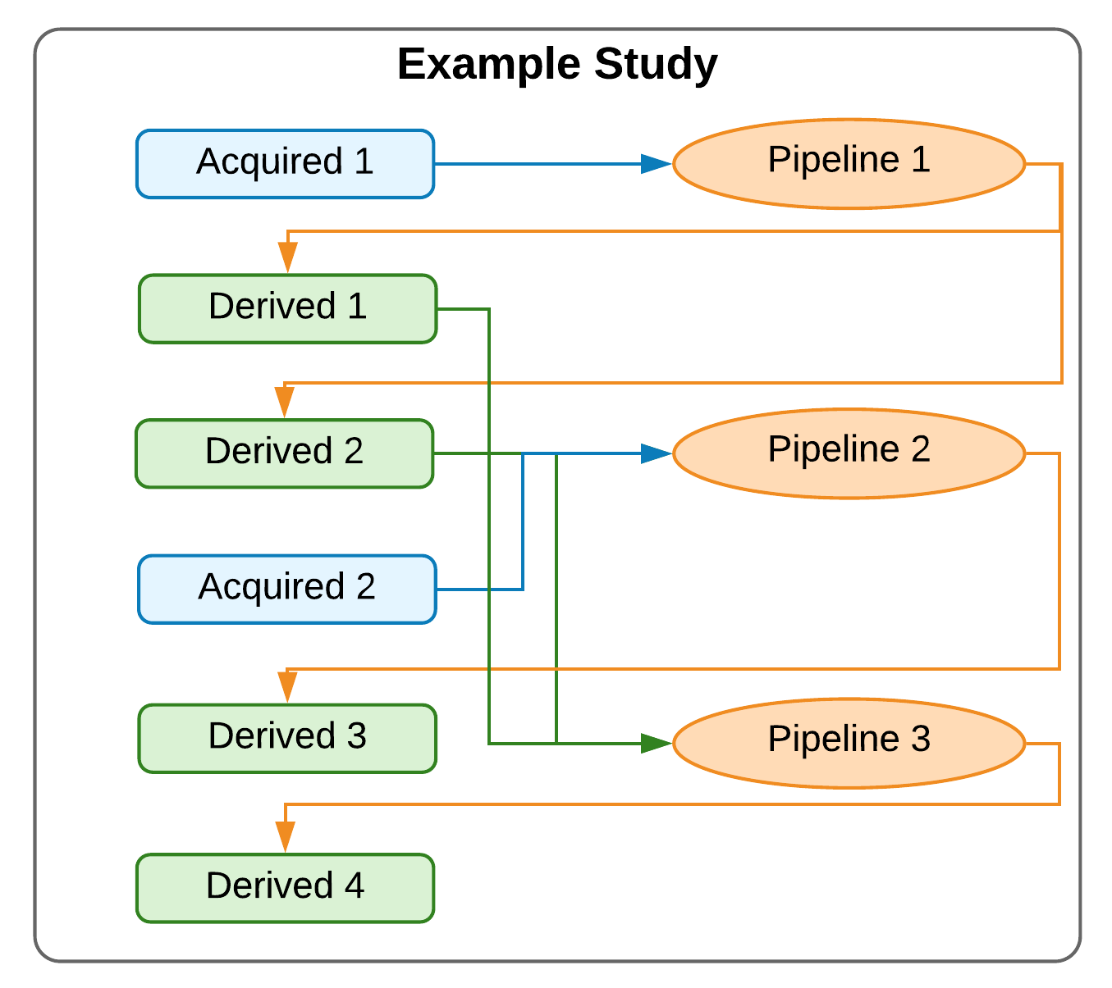

**Figure 1** - Example study. Blue boxes represent acquired (input) data (filesets or fields) stored in a repository and green derivatives from that data stored alongside the original data. Orange ovals are pipelines that operate on data in the repository to derive the derivatives. Arrows represent data flows, i.e., inputs and outputs to pipelines.

Analysis methods are applied to a specific dataset by instantiating an appropriate Study class and requesting a derivative listed in the class’ data specification table. At instantiation, a Study object is passed references to *Repository* and *Processor* objects, which define how and where data is stored and processed. When a derivative is requested, a Study object queries the repository for intermediate derivatives that can be reused before constructing a workflow to produce the requested derivative. Workflows are executed in the computing environment specified by the Processor object and their products are stored back in the repository for reuse by subsequent analyses (Figure 2). Input data to the study are also stored in the repository, and are matched against entries in the class’ data specification table using criteria defined in *Selector* objects passed to the Study object at instantiation.

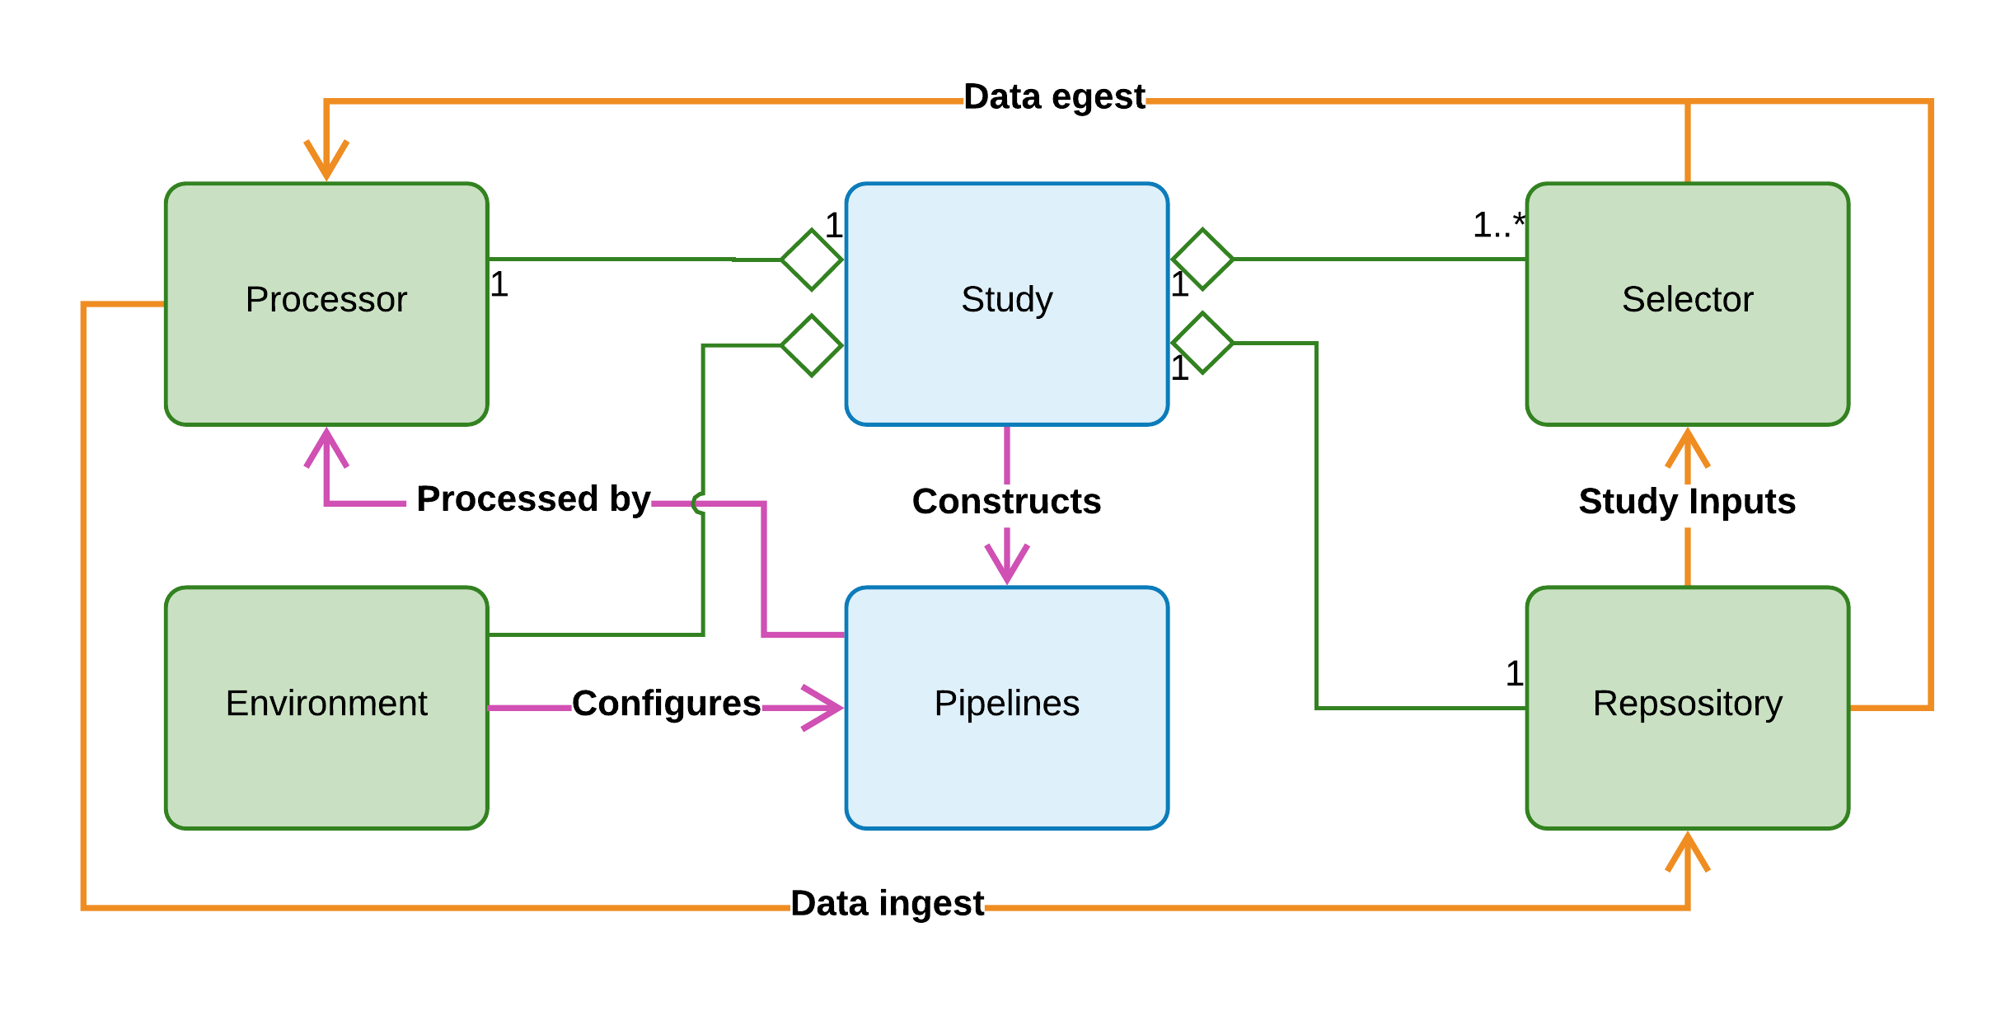

**Figure 2** - Simplified Unified Modelling Language (UML) diagram of information flow in the Arcana framework. Boxes: Python classes, blue=analysis-design, green=analysis-application. Arrows: orange=data, magenta=workflow description, diamond=aggregated-in. Study classes construct analysis pipelines, which are sent to the *Processor* to be processed. Input data is selected by *Selector* objects and pulled to the compute environment to be processed along with existing intermediate derivatives. After the derivatives are pushed back to the repository.

## Analysis design: Study classes

Study classes encapsulate a study dataset (i.e. data collected across multiple subjects using the same acquisition protocol) with the suite of analytical methods that can be applied to the dataset. The hierarchy of a study dataset is assumed to have two levels, *subjects* and *sessions*, with each session for each subject corresponding to a specific *visit*, e.g. timepoint in longitudinal study. Derivatives can be created at any point in this hierarchy: per-session, per-subject, per-visit and per-study. Iteration over subjects and visits is handled implicitly by the framework. All Study classes must inherit from the *Study* base class and be created by the *StudyMetaClass* metaclass or subclasses thereof.

### Data and parameter specification tables

At the heart of each Study class is the data specification table, which specifies both the input and output data of the analysis, and all the stages in between. There is a one-to-one relationship between entries in the data specification table and data that is stored in the repository or will be stored if and when it is derived. Which intermediate derivatives to include in the data specification table, and therefore store in the repository, is left to the discretion of the researcher designing the analysis. However, as a general rule, derivatives that require manual QC or are likely to be reused between different branches of analysis should be included in the table.

Data specified in the data specification table can be of either a *fileset* or *field* type. Filesets represent single files, header and data file pairs, or sets of related files typically contained within single directories (e.g. a multi-volume DICOM dataset). Fields represent a single integer, floating point value or character string type. Each Fileset references a *FileFormat* object, which specifies the formats of the files in the set. File formats are explicitly registered by the researcher at design time using the *FileFormat.register(format)* class method to avoid conflicts where the same extension is used for different formats in different contexts.

Fileset and field specifications are passed to the data specification of a Study class via the *add_data_specs* class attribute as a list of named *FilesetSpec* and *FieldSpec* objects (Figure 3). Specifications for acquired data (i.e. input data to the study) are distinguished from derived data by using the *AcquiredFilesetSpec* and *AcquiredFieldSpec* subtypes. However, the distinction is fluid, with derived specifications able to be overridden by acquired specifications in subclasses or MultiStudy classes, and vice-versa, or passed inputs when the class is instantiated.

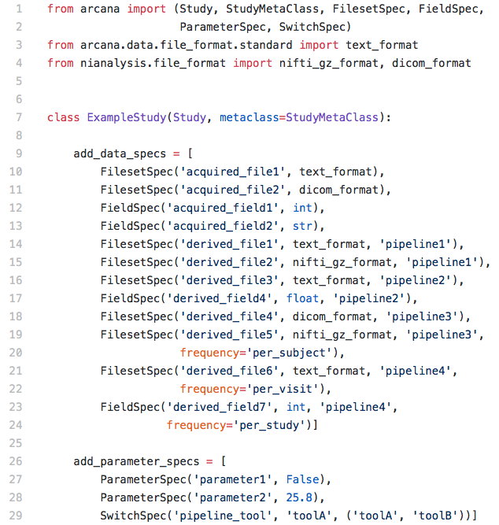

**Figure 3** - Example data and parameter specifications. The data specification specifies two “acquired” file sets, ‘one’ and ‘ten’ and ten derived file sets that can be derived from them, at least indirectly. Each derived data spec, specifies the name of the pipeline constructor that creates the pipeline that derives them. Parameter specifications specify a name and default value for free parameters of the Study class.

Both acquired and derived data specifications have a *frequency* attribute which specifies where the data sits in the hierarchy of the dataset and can take the values *per_session*, *per_subject*, *per_visit* or *per_study*. In addition, derived specifications are passed the name of a method in the class that constructs the pipeline to derive them. Therefore, while a pipeline can have multiple outputs, each derivative is derived by only one pipeline.

For fileset specifications that correspond to a known type in the BIDS standard, a *BidsSelector* or *BidsAssociatedSelector* can be provided to the *bids* keyword arg of the spec. BidsSelector specifies a primary scan in the BIDS standard using its type, modality and optional run number. BidsAssociatedSelector is used to select associated files, such as field maps and diffusion encoding matrices. When passing a BidsSelector to a FilesetSpec the *run* keyword argument of the selector is typically not set, so it can be read from the *bids_run* attribute of the Study. This allows the Study class to be applicable to any BIDS run.

Similar to data specifications, parameter specifications are included in the Study class by providing a list of *ParameterSpec* objects to the *add_parameter_specs* class attribute. ParameterSpec objects are initialised with a name and default value. Special parameters that specify a qualitative change in the analysis, for example using ANTs registration (Avants et. al. 2011) instead of FSL registration (Smith et. al. 2004), are specified by the *SwitchSpec* subtype. SwitchSpecs take a name, default value and a list of accepted values at initialisation.

### Workflow design

Analysis workflows are implemented in Arcana as a series of pipelines that each perform a unit of the analysis (e.g. registration, brain extraction). Each pipeline is in turn constructed from a (typically small) graph of Nipype nodes, with each node wrapping a stand alone tool (e.g. FSL’s FLIRT) or analysis package function (e.g. SPM’s *coreg* tool).

Pipelines are included in the analysis suite of a Study class by defining a method in the class that constructs and returns a *Pipeline* object, and referencing that method in the class’ data specification table. Pipeline objects are thin wrappers around Nipype workflows, which manage the namespaces of the workflow nodes, and should be created in constructor methods using the *Study.new_pipeline* method (Figure 4).

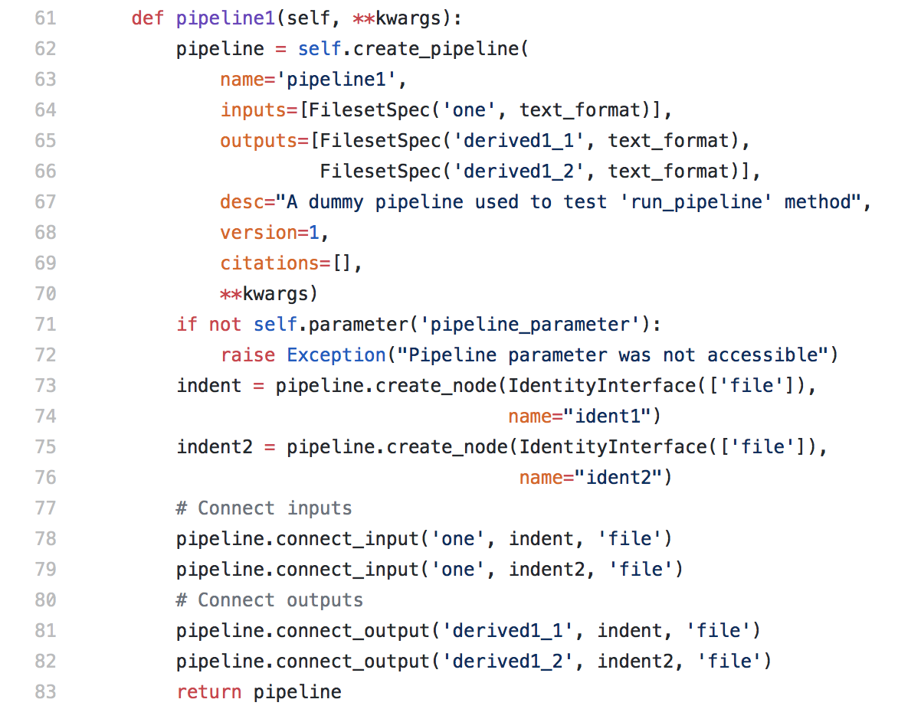

**Figure 4** - Example pipeline constructor method. Pipelines are created using the *create_pipeline* method of the Study class. Pipeline objects are thin wrappers around Nipype workflows to allow for namespace management.

At instantiation (via the new_pipeline method) a Pipeline is passed the following arguments:

* A name for the pipeline
* The inputs to the pipeline
* The output specifications the pipeline
* Description of the pipeline
* A list of scientific references the analysis was informed by
* Keyword arguments passed directly from the pipeline constructor method

Inputs and outputs refer to entries in the data specification table and specify the file formats (fileset) or data type (field) that the input is expected in, or the output will be returned in. If this format/data-type differs from that specified in the data specification table then an implicit conversion will be performed when the pipeline is executed, thereby making data conversion transparent to the researcher. Every pipeline constructor should take only wildcard keyword arguments (i.e. **kwargs), which should be passed directly through to the new_pipeline method to enable modification of the pipeline namespace by overriding methods in subclasses.

The syntax for workflow graph construction in Arcana is inspired by the proposed format for Nipype v2.0 (<https://github.com/nipy/nipype/issues/2539>), and will be updated as Nipype v2.0 is developed and upstream functionality becomes available. Workflow nodes are created from Nipype interfaces using the *Pipeline.add(name, interface)* method of the Pipeline should be used. Once created, the inputs of the node can be set explicitly via the node’s *inputs* attribute, connected to other nodes with the *Pipeline.connect(out_node, out_node_output, in_node, in_node_input)* method, or connected to inputs of the pipeline. Pipeline inputs and outputs are connected to nodes using the *Pipeline.add_input(spec_name, node, node_input)* and *Pipeline.add_output(spec_name, node, node_output)* methods, respectively.

Any external software packages required by a node should be referenced in the *requirements* keyword argument as a list of *Requirement* objects when the node added to the pipeline. These requirements can be used by the Processor to configure environment modules (Furlani, J. 1991) if present, to ensure the required software packages are available. Similarly, the expected memory requirements and wall time for the node execution should be provided as keyword args, *memory*, and *wall_time*, so they can be inserted into job scripts submitted to schedulers by HPC Processors.

Iteration over subjects and visits is handled implicitly by Arcana and depends on the frequency of the pipeline’s inputs and outputs. To create a summary derivative (i.e. frequency != *per_session*) from more frequent data a join node is used. Join nodes that join over subjects or visits are created with *Pipeline.add*_*join_subjects(name, interface, joinfield)* and *Pipeline.add_join_visits(name, interface, joinfield)* respectively. As in the underlying Nipype, the *joinfield* argument specifies which inputs of the receiving node to join into lists. If direct access to the subject or visit IDs is required by a node they can be connected to the implicit iterator nodes with *Pipeline.connect_subject_id(node, name)* and *Pipeline.connect_visit_id* respectively. Note that expansion over iterator sources is handled implicitly by Nipype when nodes with different iterators are connected to a downstream node.

Study parameters can be accessed during pipeline construction with the *Study.parameter(name)* method. If conditional logic is included in the workflow construction that alters the pipeline inputs, outputs or parameters then it should be controlled by a switch instead of a parameter. The analysis branch designated by a switch value should be tested with *Study.branch(name, ref_value)* method.

For convenience when the pipeline to construct only consists of a single node, the *Study.pipeline_constructor* classmethod to create the method (Figure 5).

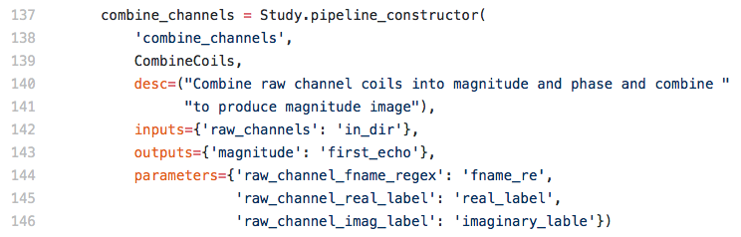

**Figure 5** - Example basic constructor defined using the *Study.pipeline_constructor* convenience method.

### Extension and specialisation by class inheritance

Because Arcana analyses are implemented as Python classes, class inheritance can be used to specialise existing analyses.

Pipeline constructors can be overridden in subclasses like any Python method. Typically the overriding method will call the superclass method to construct a base Pipeline, apply modifications and return the modified Pipeline. In this scenario, references to the data specification in the superclass method can be mapped onto different entries in the subclass by passing a dictionary containing the maps to the *name_map* keyword argument of pipeline constructor in the superclass.

Instead of setting the class attributes directly, the data and parameter specifications are set by the metaclas*s*, in order to combine with specifications from base classes. The combined data and parameter specifications are constructed by visiting the class’ bases in reverse method resolution order (MRO) and adding specifications from their *add_data_specs*, *add_parameter_specs* attributes, overriding previously added specifications with matching names. Note that in this scheme, specifications can only be appended or overridden but not removed by Study subclasses so as not to break workflows inherited from base classes.

### Implementing multi-modal studies

While basic Study classes are typically associated with single image modality or contrast, the analysis suites implemented by them can be integrated into multi-modal analysis by aggregating multiple Study classes (sub-studies) in a *MultiStudy* class. Analysis suites are integrated by joining the data specification tables of the sub-studies of a MultiStudy class. Entries in specification tables of sub-studies are joined by mapping them to a common entry in the specification table of the MultiStudy (Figure 6). This enables derivatives from one sub-study (e.g. brain extracted T1-weighted anatomical) to be referenced by workflows of other sub-studies (e.g. anatomically constrained dMRI tractography).

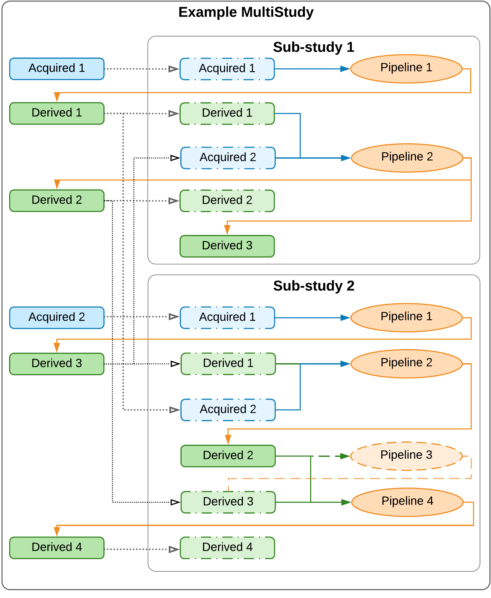

**Figure 6** - Example MultiStudy. Blue boxes represent acquired (input) data (filesets or fields) and green derivatives. Orange ovals are pipelines. Blue and green arrows: acquired and derived inputs to pipelines, respectively. Orange arrows: outputs of pipelines. Dashed boxes represent data specifications in a sub-study that are present in the global namespace and mapped into the sub-study space, and dotted arrows the mappings. Sub-studies are linked by mapping the same data spec in the global space onto data specifications the multiple sub-study namespaces (e.g. *Derived 1, 2 & 3*). There are no restrictions between mapping acquired and derivative specifications: both acquired and derivative specifications can be mapped onto acquired data or derivative specifications in sub-studies. If a spec in the global spaced is mapped onto a derivative spec in the sub-study space, then the pipeline that generates that derivative in the sub-study will not run unless it generates other required derivatives (e.g. *Pipeline 3*).

All MultiStudy classes must inherit from the Multi*Study* base class and be created by the Multi*StudyMetaClass* metaclass or subclasses thereof. As in the case of subclassing the standard Study class, additional data and parameter specifications can be added to the class via *add_data_specs* and *add_parameter_specs* respectively for additional analysis not included in the sub-studies.

Sub-studies are aggregated in the *sub-study* *specification table* of a MultiStudy class via a list of *SubStudySpec* objects in the *add_sub_study_specs* class attribute, in the manner of data and parameter specifications. A SubStudySpec consists of a name, a Study class, and a *name map* dictionary*.* The name map dictionary maps data and parameter specification names from the namespace of the MultiStudy class to the namespace of the Study class.

Entries in the specification tables of sub-study classes that are not referenced in the sub study’s name map are implicitly mapped to the MultiStudy namespace in the construction of the MultiStudy class by the metaclass using the name of the sub-study as a prefix. If the spec is a derivative then the pipeline constructor used to derive it is also mapped into the MultiStudy namespace. For example, *derived1* in *sub_study2* would be mapped to *sub_study2_derived1* along with the method *sub_study2_pipeline1*.

## Analysis application: Study instances

To apply the analysis blueprint specified in a Study class to a specific dataset, an instance of the Study class is created with details of where the data is stored (the *Repository*) and the computing environment available to process it (the *Processor*). A Study object controls the construction of analysis workflows, the execution of the workflows, and the flow of data to and from the repository (Figure 7).

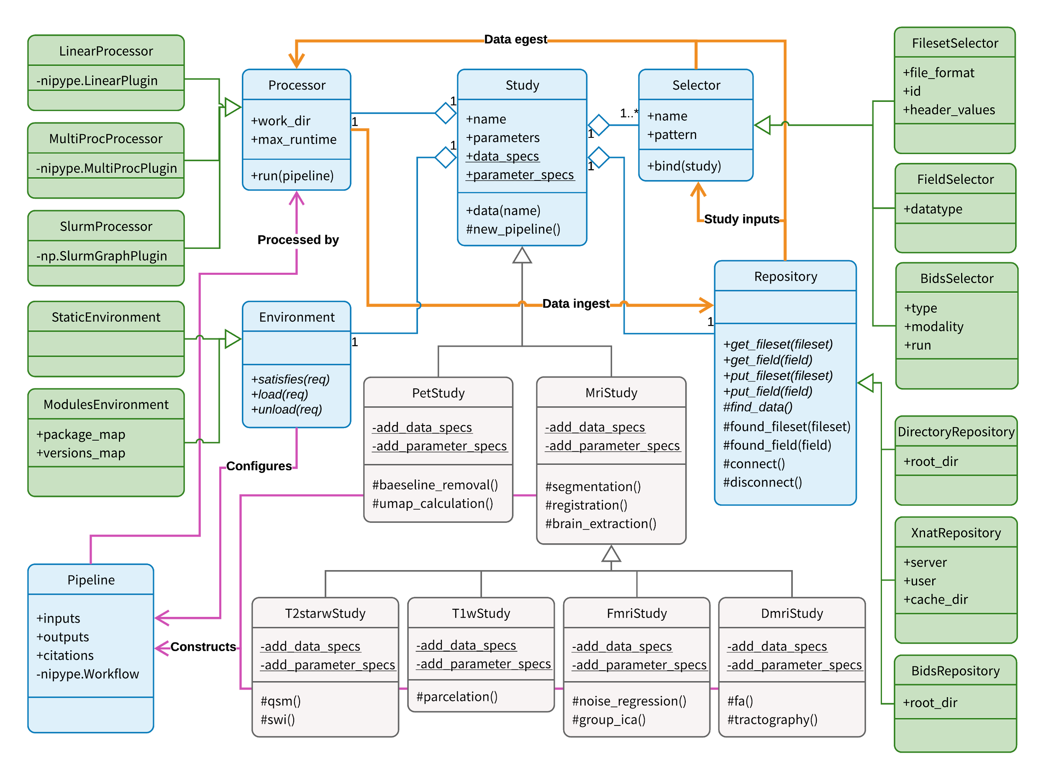

**Figure 7** - Detailed Unified Modelling Language (UML) diagram of information flow in the Arcana framework. Boxes: Python classes (blue=core, green=interchangeable modules, grey=example specialisations). Arrows: orange=data, magenta=workflow description, diamond=aggregated-in, triangle=subclass-of. Calling *data(name)* on a Study subclass constructs the requisite pipelines (as specified in *Study.data_specs*) to produce the requested data, and sends them to the *Processor* to be processed. Data is selected by *Selector* objects, pulled to the compute environment to be processed, and then the derivatives are pushed back to the repository. Repositories can be of plain directories, or BIDS or XNAT repositories.

Each Study object is assigned a name, which is used to differentiate its results from alternative analyses on the same dataset (e.g. by different members of a lab). Parameters are set on initialisation of the Study object along with the range of subject and visit IDs to be included in the analysis (if they are not provided then all IDs are included). The remaining arguments passed to the Study object initialisation are the Repository and Processor modules and a list of *Selector* objects to select input datasets from the repository (Figure 8).

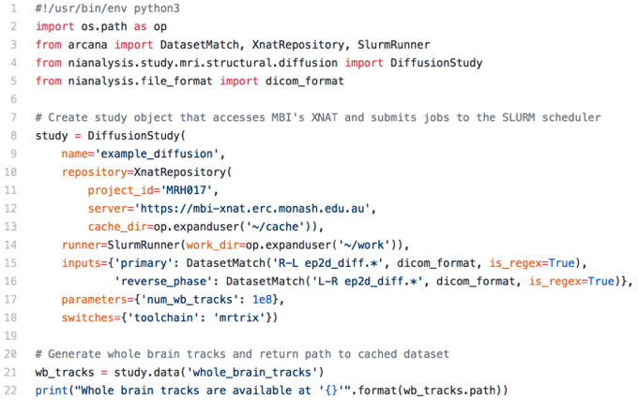**Figure 8** - Example application of Study class to a dataset stored in an XNAT repository. Once the Study object has been initialised potential derivatives of the Study can be requested, and will be generated and stored in the repository if already present.

### Repository modules

In Arcana, repository access is encapsulated within modular *Repository* objects to enable switching between different repositories and repository types at analysis “application time” (Figure 2). There are currently three supported repository types, XNAT (Marcus et al. 2007), BIDS (Gorgolewski et al. 2016) and a simple “directory” format, which are encapsulated by *XnatRepository*, *BidsRepository*, and *DirectoryRepository* classes respectively.

In its most basic form, a directory repository is just a file system directory with separate subdirectories for each subject in the study, with subject IDs taken from the subdirectory names. If the study has more than one visit then nested subdirectories for each visit are required in the subject subdirectories. Note that the directory repository is similar to the BIDS format, however, there are no naming conventions in the directory repository, which enables prototyping and testing of analyses on loosely structured data.

Derivatives are stored by their specification name in a study-specific namespaces to avoid clashes with separate analyses. In directory repositories this namespace is a subdirectory named after the study nested within each visit subdirectory if present or subject subdirectory otherwise. In BIDS repositories, the namespace is a subdirectory of the *derivatives* directory, again named after the study. In XNAT repositories, derivatives for each session are stored in separate *MrSession* objects alongside the primary session underneath its *Subject*, and are named *<primary-session-name>_<study-name>* (Table 1).

Derived filesets are stored with the format specified in the study’s data specification. In plain-directory and BIDS repositories, fields are stored in a single JSON file named ‘__fields__.json’ in each derived session, and on XNAT they are stored in custom fields of the derived session. Provenance is stored in a ‘__prov__’ sub-directory (dataset on XNAT) of the derivatives directory (MrSession on XNAT) in separate JSON files for each pipeline named after the pipeline (Table 1).

Summary data (i.e. with *per_subject*, *per_visit*, and *per_study* frequencies*)* are stored in specially named subjects and visits (e.g. ‘all’), the names for which are specified when the repository is initialised. For example, given in plain-directory repository using all as the summary name for both subjects and visits, per_subject data for ‘subj1’ would be stored at *<root-dir>/subj1/*all, per_visit data for ‘visit1’ in *<root-dir>/*all*/visit1*, and per_study data in *<root_dir>/*all/all (Table 1).

|  |  |  |  |
| --- | --- | --- | --- |
|  | **Plain-directory** | **BIDS** | **XNAT** |
| **Derivatives** | */subject/visit/study* | /derivatives/study/subject/visit | /subject/*visit_study* |
| **Fields** | *.../*__fields__*.json* | *.../*__fields__*.*json | “custom variables” |
| **Provenance** | *.../*__prov__*/pipeline.*json | *.../*__prov__*/pipeline.*json | .../scans/__prov__/resources/*pipeline/*prov*.*json |
| **per_subject** | */subject/*all*/study* | */derivatives/study/subject/*all | */subject/*all_*study* |
| **per_visit** | */*all*/visit/study* | */derivatives/study/*all*/visit* | */*all*/visit_study* |
| **per_study** | */*all*/*all*/study* | */derivatives/study/*all*/*all | */*all*/*all_*study* |

**Table 1** - Storage locations of derived data for each repository type. Derivatives are stored in separate namespaces for each Study instance to enable multiple analyses on the same datasets with different parameterisations. ‘...’ refers to the *Derivatives* directory/xnat:MrSession.

Each study can only have one repository in which derivatives are stored. However, a study can draw data from multiple auxiliary repositories, which are specified in the inputs passed to the study. When using multiple input repositories, subject and visit IDs will often need to be mapped from their values in the auxiliary repositories to the “ID space” of the study. This mapping is specified using *IdMapper* objects passed to *subject_id_map* and *visit_id_map* keyword arguments during initialisation of a repository.

New repository modules for additional repository types can be implemented by extending the Repository abstract base class and implementing a small set of methods (Table 2).

|  |  |
| --- | --- |
| **Method name** | **Function** |
| find_data() | Queries repository to find all existing filesets and fields and registers them with the *Repository.found_fileset(fileset)* and *Repository.found_field(field)* methods respectively. |
| get_fileset(Fileset) | Caches the files in a Fileset locally and returns the path to the primary file or directory in the cache. |
| get_field(Field) | Retrieves and returns the value of the field from the repository |
| put_fileset(Fileset) | Inserts the files in the Fileset into the repository and updates the local cache. |
| put_field(Field) | Inserts the value of the Field into the repository |
| connect() | Opens a connection to the repository (optional). Called by methods in the base class before entering outer processing loops. |
| disconnect() | Closes connection to repository opened by *connect()* method (optional) |

**Table 2** - Abstract methods in the base Repository class that need to be implemented by platform-specific sub-classes.

### Study inputs

While derivatives generated by a Study object are named in accordance with the data specification of the Study class, arbitrary naming conventions can be used for input datasets and fields to allow for heterogeneity in acquisition procedures. A selection stage is therefore necessary to match input data to appropriate entries in the data specification table of the Study class. The criteria for this selection is passed to the Study object at instantiation and is required to match exactly one fileset or field in every session included in the study.

Selection criteria are specified by list of *FilesetSelector* and *FieldSelector* objects provided to the *inputs* argument of the Study initialisation method. Matching is typically performed on file names (dataset labels for XNAT repositories), and field names. If the names are inconsistent across the study then regular expressions can be used instead of exact matches by passing *is_regex=True* when initialising the Selector. Additional criteria can be used to distinguish cases where multiple filesets in the session match the pattern provided, such as DICOM header values, or when using an XNAT repository, the order and ID of the dataset.

Inputs can be drawn from auxiliary repositories by providing alternative Repository instances to the *repository* keyword of the Selector. Care should be taken to ensure that the subject and visit ID schemes will map correctly to that of the primary repository (see *Repository modules*). If the primary repository is empty (i.e. all inputs come from auxiliary repositories) then explicit *subject_ids*, *visit_ids* need to be provided and the *fill_tree* flag set when initialising the Study.

If the data to select has been derived from an alternative study, then the name of the alternative study can be passed to the *from_study* keyword argument provided to the selector. There are no restrictions on selecting any data, derived or otherwise, to match acquired or derived specifications. For example, it is possible to deliberately skip analysis steps by selecting an output of an early step in a previous run as a match for a later derived spec although this is not recommended as standard practice.

Specific files and fields that are not stored within a repository can be passed as inputs in *FilesetCollection* and *FieldCollection* objects. Collection objects reference an entry in the data specification table and contain a single Fileset or Field for every session (or subject/visit/study depending on the frequency of the corresponding data spec). Collection objects can be used to pass reference atlases and templates as inputs to analyses. They can also be set as the “default input” for a data spec using the *default_input* keyword argument. For the sake of portability, default inputs should be restricted to data in publically accessible repositories or included in standard software packages (e.g. FSL).

When using BIDS repositories, the selection stage is typically already included in the data specification (see *Data and parameter specifications)* so inputs do not need to be provided to the initialisation of the Study. However, BidsSelector and BidsAssociatedSelector objects can be provided to override the default selections is required.

### Processor modules

Processor modules control how and where pipelines generated by a Study are executed. There currently four Processor modules implemented in Arcana: *LinearProcessor*, *MultiProcProcessor*, *SlurmProcessor* and *SgeProcessor*, which wrap the correspondingly named Nipype execution plugins. The main task performed by the processor, as separate from the Nipype execution plugin it wraps, is to determine which pipelines need to be run and link them into a single workflow. Since this logic is implemented in the Processor abstract base class, wrapping additional Nipype plugins as required is trivial.

A processor is used internally by a Study instance to execute pipelines to derive derivatives requested from the data specification by the *Study.data(name[, name,...])* method (Figure 2). The first step in this procedure is to query the repository tree for all data and provenance associated with the study. Sessions for which the requested outputs of the pipeline are already present in the repository are excluded from the list to process. For the remaining sessions to process, inputs of the pipeline that are derivatives themselves are added to the stack of requested derivatives. This procedure is repeated recursively until there are no sessions to process or all inputs to the pipeline are study inputs at a given depth.

When a pipeline is processed it is connected to *Source* and *Sink* nodes, which get and put the pipeline inputs and outputs from and to a repository, respectively. Separate source and sink nodes are used for each data frequency (i.e. per-session, per-subject, per-visit, per-study). If implicit file format conversion is required (i.e. the input or output format differs from the data specification) then additional format converter nodes are inserted after the source nodes or before the sink nodes. Iterator nodes that iterate over the required subjects and visits are connected to the sources, and report nodes that join over subjects and visits are connected to the sink nodes. Report nodes of upstream pipelines are connected to downstream iterator nodes to create a single workflow, which is then executed using the Nipype execution plugin.

Software versions are managed by the processor if environment modules (Furlani 1991) are installed on the system. These are loaded and unloaded before the interface of a workflow node is run based on the requirements specified for the node during construction of the pipeline (see *Pipeline constructors*). Maps from requirement names to module names in the processing environment can be passed to the Processor at initialisation. For plugins that submit jobs to HPC schedulers (e.g. SLURM, SGE), node memory and wall-time requirements are inserted into jobscripts where required.

Provenance is stored for each pipeline run alongside the generated derivatives and consists of: parameter values used by the pipeline, software versions used by the pipeline, a graph representation of the underlying Nipype workflow, checksums of inputs, version of Arcana used, version of Nipype used, subject and visit IDs used by study.

For subsequent analyses, changes w.r.t. Any of the stored values, with the exception of subject and visit IDs, will be flagged as a mismatch. Subject or visit IDs only flag a mismatch if any of the inputs, or inputs of upstream pipelines, are per-visit or per-subject, respectively, or per-study. How provenance mismatches are handled by the study is determined by the *reprocess* flag, which is passed to the Study on initialisation (Table 3).

|  |  |
| --- | --- |
| ***Repocess* flag value** | **Behaviour when mismatching derivatives are found** |
| False (default) | An exception will be raised |
| True | Mismatching derivatives will be reprocessed |
| ‘Ignore’ | Mismatches will be ignored |
| ‘ignore_versions’ | Version mismatches will be ignored, other mismatches cause an exception to be raised |
| ‘ignore_versions_true’ | version mismatches will be ignored, other mismatches will cause the derivative to be reprocessed |

**Table 3** - Effect of the *reprocess* flag value on the behaviour of the study when existing derivatives are found that were derived with mismatching inputs and parameters.

Additionally, a time limit can be passed to the *reprocess_time_limit*, and if the estimated time to reprocess all the required sessions is less than the time limit they will be reprocessed and otherwise an exception will be raised.

# Results

The Arcana framework is distributed as a publicly available software package via GitHub (<http://github.com/MonashBI/arcana>) and the Python Package Index (PyPI) ([http://pypi.org/project/arcana/](https://pypi.org/project/arcana/)). Study classes for T1, T2* and diffusion weighted MRI data have been implemented as part of the *Biomedical imAgiNg ANAlysis (Banana)* package ([http://github.com/MonashBI/banana](https://github.com/MonashBI/banana); <http://pypi.org./project/banana>). All three classes, *T1wStudy*, *T2starwStudy* and *DmriStudy*, inherit generic image analysis methods, such as registration and brain extraction, from the base class *MRIStudy*. The T1Study and T2starStudy classes are aggregated into the *T2starwT1wStudy* MultiStudy class to combine analysis of T2* and T1-weighted contrasts.

The DmriStudy class implements diffusion tensor metrics, FA and ADC, as well as global tractography using streamlines tracking from the MRtrix toolbox (Tournier et. al. 2010; Tournier et. al. 2012) (Figure 9).

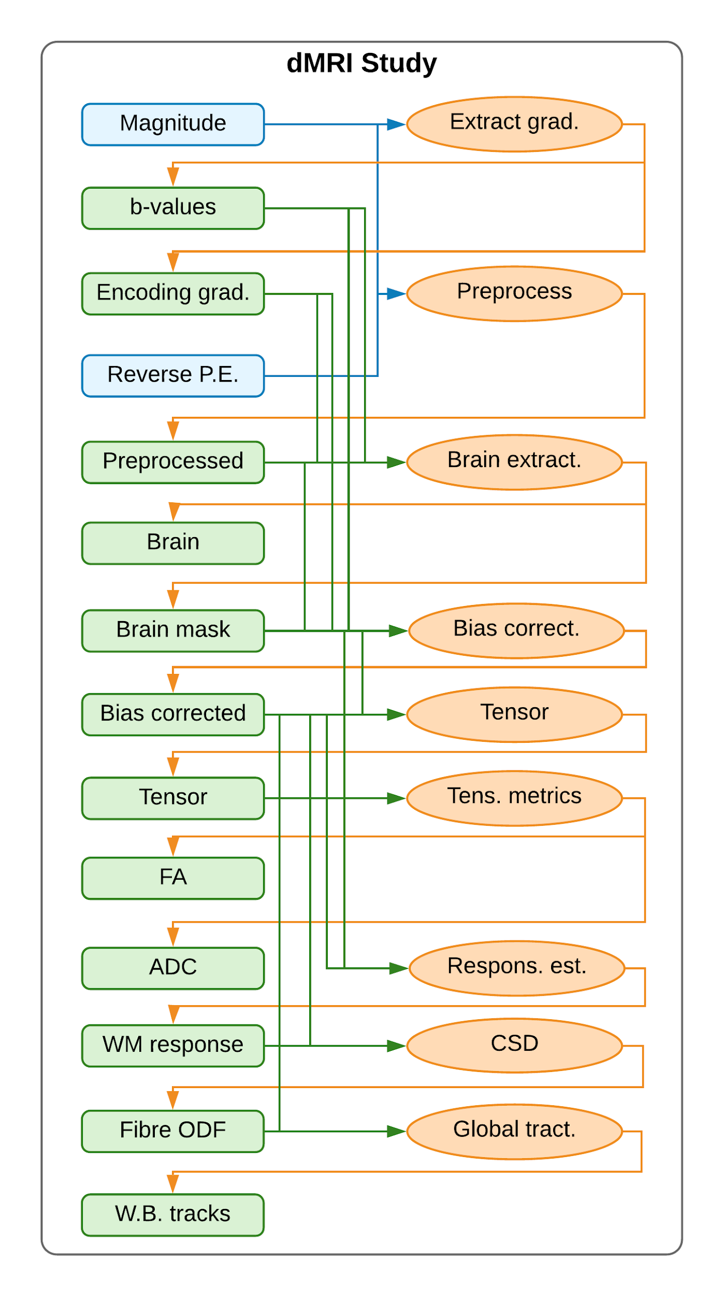

**Figure 9** - Example diffusion MRI (dMRI) study, which can derive tensor metrics, fractional anisotropy (FA) and apparent diffusion coefficient (ADC) as well as streamlines fibre tracking. Blue boxes: acquired (input) data (filesets or fields). Green boxes: derivatives. Orange ovals: pipelines. Blue and green arrows: acquired and derived inputs to pipelines, respectively. Orange arrows: outputs of pipelines. The dMRI magnitude image is preprocessed for motion correction and EPI distortions masked and bias corrected. From the bias corrected image two branches of analysis can be performed using the same intermediate derivatives: FA and ADC and/or streamlines fibre tracking.

The *T2starwT1wStudy* class implements an algorithm to generate *composite vein images* from the combination of QSM and SWI contrasts derived from the T2*-weighted acquisition with an vein atlas registered to the T1-weighted acquisition (Ward 2018) (Figure 10).

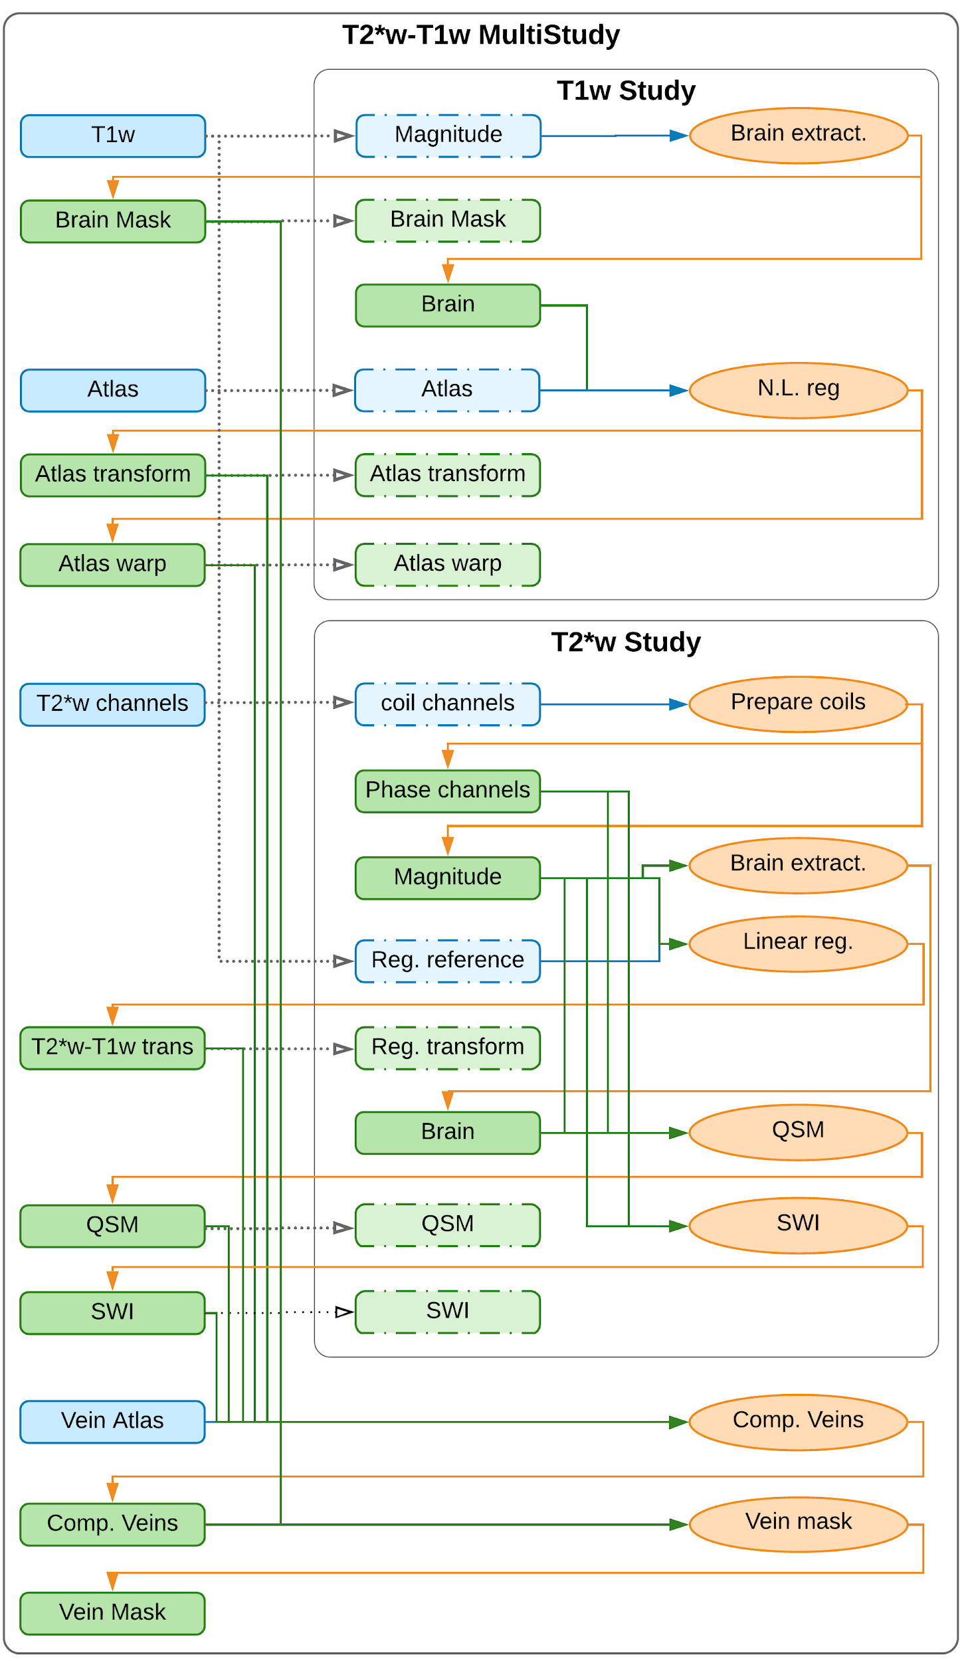

**Figure 10** - Combined T1-weighted/T2*-weighted multi-study, which can derive vein masks by combining Quantitative Susceptibility Mapping (QSM) and Susceptible Weighted Imaging (SWI) contrasts with a manual atlas. Blue boxes: acquired (input) data (filesets or fields). Green boxes: derivatives. Orange ovals: pipelines. Blue and green arrows: acquired and derived inputs to pipelines, respectively. Orange arrows: outputs of pipelines. Dashed boxes represent data specifications in a sub-study that are present in the global namespace and mapped into the sub-study space, and dotted arrows the mappings. The acquired T1-weighted image is mapped to both the *magnitude* spec of the T1-weighted sub-study and the *registration reference* spec of the T2*-weighted sub-study. The nonlinear transformation from subject to atlas space are mapped from the T1-weighted sub-study and combined with the linear registration between T1-weighted and T2*-weighted images, QSM and SWI images mapped from the T2*-weighted sub-study to produce the composite-vein image. The brain mask from the T1-weighted sub-study is combined with the composite vein image to produce the vein mask.

The DiffusionStudy and T2starT1Study classes are further aggregated in turn into a single MultiStudy class for the results section of this manuscript*, ArcanaPaper*, (Figure S.1-5). Methods are implemented in ArcanaPaper to generate and display the derivative images in Figures 11, 12, and 13.

To test the analysis workflows implemented in ArcanaPaper, a healthy volunteer was scanned using a 3T Siemens Skyra with a 32-channel head and neck coil. The protocol was a T1-weighted MPRAGE (1mm contiguous, matrix size 256x240x192, FOV 256x240x192, TE = 2.13ms, TR, = 2300ms, TI = 900ms, bandwidth=230Hz/pixel), GRE (1.8 mm contiguous, matrix size 256x232x72, FOV 230x208x130, TE = 20ms, TR, = 30ms, bandwidth=120Hz/pixel), diffusion MRI (1.2 mm contiguous, matrix size 110x100x60, FOV 256x240x192, TE = 95ms, TR, = 8200ms, 33 diffusion directions with b=1500 mm2/s and 3 b=0, bandwidth=781Hz/pixel) (**cite Lifespan paper ??**). Methods for Figure 11, 12, and 13 in the ArcanaPaper class were applied to the acquired dataset to using the *SlurmProcessor* to submit jobs to the the MASSIVE HPC cluster (Goscinski 2014) in order to generate the figures.

Figure 11 displays composite vein images and vein masks for the healthy volunteer along with the SWI and QSM intermediate derivatives and the input vein atlas. The derived vein images are comparable to those generated by the original implementation (Ward 2018). The complete workflow took ?? min to complete over ?? compute cores.

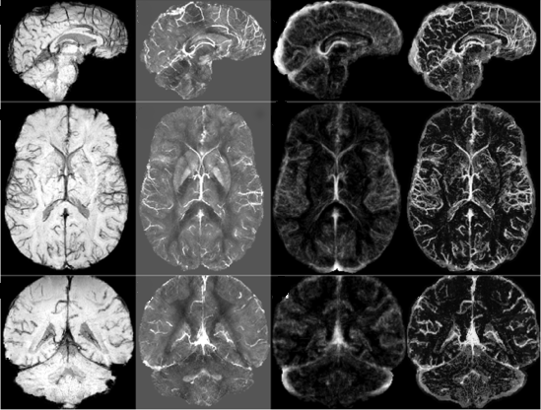

**Figure 11 -** Vein image (*right column*) constructed by combining susceptibility weighted imaging (SWI) (*left column*), quantitative susceptibility mapping (QSM) (*left-middle column*) and a vein atlas from manual tracings (*right-middle column*). *Top row*: sagittal slices. *Middle row*: axial slices. *Bottom row*: coronal slices.

Figure 12 displays the FA and ADC maps derived from the diffusion MRI acquisition. The FA map shows high intensity in known white matter tracts and low intensities in known grey matter regions. The ADC map shows high intensity in cortical spinal fluid and low intensity through the rest of the brain.

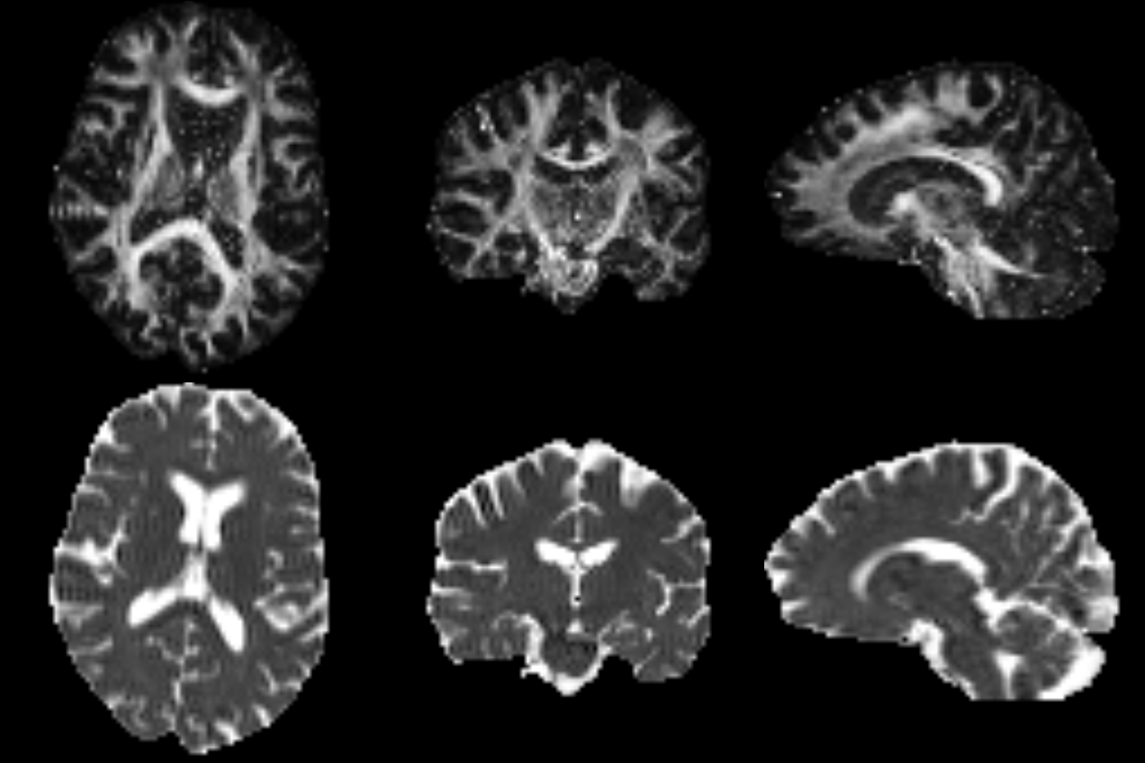

**Figure 12 -** Fractional Anisotropy (FA) *(top row)* and Apparent Diffusion Coefficient (ADC) (*bottom rowI)* derived from diffusion MRI data. *Left column:* axial midline slices. *Middle column:* coronal midline slices. *Left column*: sagittal midline slices.

Figure 12 displays the global tractography derived from the dMRI acquisition. The streamlines follow well known white matter tracts such as the cortico-spinal, fasciculus and corpus callosum. Intermediate derivatives derived for the FA and ADC analysis, including the preprocessed and bias-corrected dMRI image and a whole brain mask, were reused in the generation of the streamlines reducing the time taken to produce the tractography results from ?? to ??.

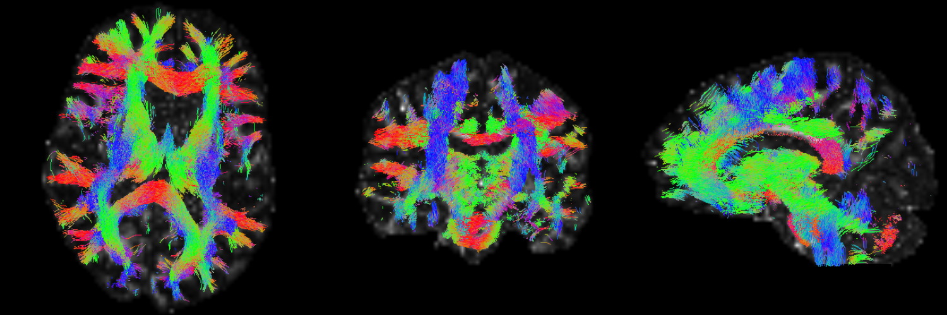

**Figure 13 -** Global tractography performed using the MRtrix toolbox. Probabilistic streamlines generated with the iFOD2 algorithm from fibre Orientation Distribution Function (fODF) estimated from diffusion MRI datasets using Constrained Spherical Deconvolution (CSD). Streamlines are colour-encoded by orientation: green=anterior-posterior, blue=inferior-superior, red=left-right. *Left panel:* axial midline slice. *Middle panel:* coronal midline slice. *Left panel*: sagittal midline slice.

# Discussion

We present Arcana, a software framework to facilitate the development of comprehensive analysis suites for neuroimaging data that implement complete workflows from repository data to publication results. The encapsulation of repository data and workflow generation in Arcana enables researchers to create robust workflows while focussing on the core logic of their analysis. Arcana’s modular pipeline and OO architecture promotes code reuse between different workflows by facilitating the sharing of common segments (e.g. registration, segmentation). The clear separation of analysis design from its application leads to portable workflows, which can be applied to datasets stored in a number of storage systems. In addition, the management of intermediate derivatives, provenance and software versioning, coupled with ability to submit jobs to HPC clusters, enables workflows implemented in Arcana to scale to large datasets. Arcana thereby enables researchers to quickly prototype analysis suites on local workstations that can be deployed on enterprise-scale infrastructure without modification.

Software frameworks (Yacoub and Ammar 2004) have been successful in improving code quality and efficiency of development in a variety of contexts (Moore et. al. 2008; White 2012; Abadi et. al. 2016). By factoring out common elements, only features that are specific to the given application need to be implemented by the analysis designer, and the common elements become battle hardened through repeated use. Arcana handles many of the menial tasks involved with workflow implementation, such as data retrieval and storage, format conversions, and provenance, reducing the time and effort required to implement robust workflows from acquired data to publication results.

An oft-repeated mantra in the open-source software movement dubbed Linus’ Law is that "given a large enough beta-tester and co-developer base, almost every problem will be characterized quickly and the fix obvious to someone" or more compactly, "given enough eyeballs, all [bugs](https://en.wikipedia.org/wiki/Software_bug) are shallow" (Raymond 1999). Given the size of the neuroimaging research community, there are a large number of potential beta-testers and co-developers. However, it has been difficult for researchers to collaborate on the same code base due to slight differences in acquisition protocols, storage conventions, researcher preferences, and study requirements.

The flexibility and portability of the Arcana framework increases the feasibility of community collaborations on workflow implementations. The improvement of code quality in larger community efforts, due to more eyeballs to detect and fix errors, has the potential to form a reinforcing cycle where in more developers are attracted to the project. To these ends, the Banana code repository on GitHub (<http://github.com/MonashBI/banana.git>) is proposed as a code base for communal development of neuroimaging workflows in Arcana.

A level of proficiency in Python OO design is required to design new analyses in Arcana, which may preclude inexperienced programmers. However, only a basic knowledge of Python is required to apply existing analyses to new datasets. Furthermore, a number of example Study classes have been implemented, which can guide the hand of analysis designers. Arcana imposes a consistent structure on workflows implemented within it, making the code easier to understand for developers who are familiar with the framework. In addition, class inheritance provides a manageable way to adapt and extend to existing analyses and highlights where modified analyses differ from standard procedures.

MR contrast-specific analyses are implemented in NiAnalysis via a chain of successively specialised Study sub-classes (e.g. MRI>EPI>dMRI) to enable generic processing steps (e.g. registration) to be shared between classes. While not necessary, it is recommended to create a subclass specific to the research study in question and aggregate all related analysis within it, since such classes can be applied to alternate datasets in order to reproduce the exact analysis. The *ArcanaPaper* class (Figure S.1-5), which contains methods to generate all figures in the Results section of this manuscript, is an example of this approach.

The abstraction of data and repositories in Arcana enables the same workflow implementation to be applied to datasets stored in BIDS format or XNAT repositories. A single code-base can therefore be containerized into BIDS apps or XNAT pipelines without adaptation, helping to form a bridge between the two communities of users and developers. Alternative data storage systems (Book et. al. 2009; Das et. al. 2011, Scott et. al 2011), can be integrated into Arcana by overriding a small number of methods from the Repository abstract base class. Repository modules could also be created for data portals such as *DataLad* (Halchenko 2018) in order to take advantage of the range of platforms they support. Implementing analyses in Arcana therefore enables researchers and research groups to easily migrate their workflows between storage platforms, and not risk being locked in to a particular technology.

While Arcana was primarily developed for neuroimaging datasets, it is a general framework that could be applied to data from other fields. However, in other contexts, the subject and visit hierarchy may no longer make sense. In many cases it may be sufficient to map subjects and/or visits onto alternative concepts (e.g. for meteorological data *subjects* = *weather stations*, *visits = observation times*). But some cases may require a deeper data hierarchy (i.e. greater than two), which is not currently possible in Arcana.

Ensuring that the consistent versions of external tools are used throughout the analysis is important to avoid introducing biases due to algorithm updates. In systems with environment modules (Furlani 1991) installed, Arcana loads and unloads the required modules before and after each node is executed. When running Arcana within a container, environment modules and software versions can be installed inside the container giving exact control over the versions used. To these ends, a Docker container is available on Docker Hub, (<http://hub.docker.com/r/monashbi/banana>), which can be used as a base for neuroimaging analysis containers.

While the same tools and versions should be applied across an analysis to avoid bias, there are cases where it is desirable to rerun the same analysis with different tools substituted at various points in the workflow. In particular, when introducing new tools or upgrades to existing tools, it is important to show the effect on the final results in comparison with existing methods. Furthermore, it is typically not clear what variability between results produced by comparable tools is due to. Therefore, in the absence of *a priori* reason to favour a particular tool, perhaps the most rigorous approach is to rerun analyses with different combinations of available tools and only present results that are robust to the “analytic noise” (cite here?) they introduce. Switch parameters make it straightforward to rerun analyses in Arcana with substituted tools while controlling all other aspects of the workflow.

Arcana’s management of intermediate derivatives and provenance guarantees that the same analysis is applied across the dataset without necessarily requiring a complete rerun of the analysis. This guarantee makes it feasible to process data as it is acquired over the course of long studies, and therefore help detect any problems that might arise with the acquisition protocol when they occur. In addition, by reusing shared intermediate derivatives between analyses, such as the preprocessed dMRI shared between tensor and fibre tracking workflows (Figures 12 and 13), processing time as well as time required for manual QC is minimised. Given analyses implemented in Arcana are also able to be processed on HPC clusters, they scale well to large studies.

# Conclusion

By managing the complete flow of data from/to a repository with modular components, Arcana enables complex analyses of large-scale neuroimaging studies that are portable across a wide range of research sites. The extensibility of analyses implemented in Arcana, coupled with the flexibility afforded by programmatic constructuction of pipelines, facilitates the design of comprehensive analyses by larger communities. Larger communities of developers working on the same code-base should make it feasible to capture the arcana of neuroimaging analysis in templates that can be applied to a wide range of relevant datasets.

# References

Abadi, M., Barham, P., Chen, J., Chen, Z., Davis, A., Dean, J., Devin, M., Ghemawat, S., Irving, G., Isard, M., Kudlur, M., Levenberg, J., Monga, R., Moore, S., Murray, D. G., Steiner, B., Tucker, P., Vasudevan, V., Warden, P., Wicke, M., Yu, Y., Zheng, X.. (2016). TensorFlow: A System for Large-Scale Machine Learning TensorFlow: A system for large-scale machine learning. *12th USENIX Symposium on Operating Systems Design and Implementation (OSDI ’16)*, 265–284. <https://doi.org/10.1038/nn.3331>

Achterberg, H. C., Koek, M., & Niessen, W. J. (2016). Fastr: A Workflow Engine for Advanced Data Flows in Medical Image Analysis. *Frontiers in ICT*, 3(August), 1–11. <https://doi.org/10.3389/fict.2016.00015>

Amstutz, P., Crusoe, M. R., Tijanić, N., Chapman, B., Chilton, J., Heuer, M., Kartashov, A., Leehr, D., Ménager, H., Nedeljkovich, M., Scales, M., Soiland-Reyes, S., Stojanovic, L. (2016). Common workflow language, v1. 0. Figshare. doi:[10.6084/m9.figshare.3115156.v2](https://doi.org/10.6084/m9.figshare.3115156.v2)

Avants, B. B., Tustison, N. J., Song, G., Cook, P. A., Klein, A., & Gee, J. C. (2011). A reproducible evaluation of ANTs similarity metric performance in brain image registration. *NeuroImage*, *54*(3), 2033–2044. <https://doi.org/10.1016/J.NEUROIMAGE.2010.09.025>

Book, G. A., Anderson, B. M., Stevens, M. C., Glahn, D. C., Assaf, M., & Pearlson, G. D. (2013). Neuroinformatics Database (NiDB)–a modular, portable database for the storage, analysis, and sharing of neuroimaging data. *Neuroinformatics*, *11*(4), 495-505.

Cox, R. W. (1996): AFNI: Software for analysis and visualization of functional magnetic resonance neuroimages. *Computers and Biomedical Research*, 29:162-173.

Cusack R., Vicente-Grabovetsky A., Mitchell D.J., Wild C.J., Auer T., Linke A.C., Peelle J.E. (2015) Automatic analysis (aa): Efficient neuroimaging workflows and parallel processing using Matlab and XML. *Frontiers in Neuroinformatics* 8:90.

Das, S., Zijdenbos, A. P., Harlap, J., Vins, D., & Evans, A. C. (2012). LORIS: a web-based data management system for multi-center studies. *Frontiers in Neuroinformatics*, 5(January), 1–11. <https://doi.org/10.3389/fninf.2011.00037>

Esteban O. (2018) FMRIPrep: a robust preprocessing pipeline for functional MRI. *bioRxiv.* 306951; doi:[10.1101/306951](https://doi.org/10.1101/306951)

Friston K. (2007): Statistical parametric mapping. In:. *Statistical Parametric Mapping*. Elsevier. pp 10–31.

Furlani, J. (1991). Modules: Providing a flexible user environment. *Proceedings of the Fifth Large Installation Systems Administration Conference (LISA V)*, (1), 141–152.

Gorgolewski K.J. et al. (2011), ‘Nipype: A Flexible, Lightweight and Extensible Neuroimaging Data Processing Framework in Python’. *Frontiers in Neuroinformatics*, vol. 5.

Gorgolewski K. J. et al. (2016): ‘The brain imaging data structure, a format for organizing and describing outputs of neuroimaging experiments’. *Scientific Data*, vol. 3.

Goscinski, W. J., P. McIntosh, U. C. Felzmann, A. Maksimenko, C. J. Hall, T. Gureyev, D. Thompson, A. Janke, G. Galloway, N. E. B. Killeen, P. Raniga, O. Kaluza, A. Ng, G. Poudel, D. Barnes, T. Nguyen, P. Bonnington and G. F. Egan (2014). "The Multi-modal Australian ScienceS Imaging and Visualisation Environment (MASSIVE) high performance computing infrastructure: applications in neuroscience and neuroinformatics research." *Frontiers in Neuroinformatics* 8.

Halchenko, Y., Hanke, M., Poldrack, B., Meyer, K., Debanjum, Alteva, G., … Feilong Ma. (2018). Datalad/Datalad 0.10.2. Zenodo. https://doi.org/10.5281/zenodo.808846

Kennedy, D. N. (2018). Neuroimaging Neuroinformatics: Sample Size and Other Evolutionary Topics. *Neuroinformatics*, 16(2), 149–150. <https://doi.org/10.1007/s12021-018-9379-8>

Marcus D. S. et al. (2007), ‘The extensible neuroimaging archive toolkit’. *Neuroinformatics*, vol. 5, pp. 11–33.

Moore, D., Budd, R., & Wright, W. (2008). *Professional Python Frameworks: Web 2.0 Programming with Django and Turbogears*. John Wiley & Sons.

Paszke, A., Chintala, S., Collobert, R., Kavukcuoglu, K., Farabet, C., Bengio, S., ... & Mariethoz, J. Pytorch: Tensors and dynamic neural networks in python with strong gpu acceleration, may 2017.

Raymond, E. S. (1999). The Cathedral and the Bazaar. O'Reilly Media. ISBN 1-56592-724-9. pp. 30.

Scott, A., Courtney, W., Wood, D., De la Garza, R., Lane, S., Wang, R., ... & Calhoun, V. D. (2011). COINS: an innovative informatics and neuroimaging tool suite built for large heterogeneous datasets. *Frontiers in neuroinformatics*, *5*, 33.

Smith S. M. et al. (2004): Advances in functional and structural MR image analysis and implementation as FSL. *NeuroImage* vol. 23, pp. S208–S219.

Sudlow C. et al. (2015) UK Biobank: An Open Access Resource for Identifying the Causes of a Wide Range of Complex Diseases of Middle and Old Age. *PLoS Medicine*;12:e1001779.

Schreiber J. et al (2018) ‘Using a Multi-Petaflop Supercomputer for Pushing Neuroimaging Analytics to the Next Level’, In: *Proceedings of Organisation for Human Brain Mapping 2018*, Singapore, Singapore

Tournier, J. D., Calamante, F., & Connelly, A. (2010). Improved probabilistic streamlines tractography by 2nd order integration over fibre orientation distributions. In *Proceedings of the international society for magnetic resonance in medicine* (Vol. 18, p. 1670).

Tournier J.D. et al. (2012): ‘MRtrix: Diffusion tractography in crossing fiber regions’. *International Journal of Imaging Systems and Technology*, vol. 22, pp. 53–66.

Thompson P.M. et al. (2014): ‘The ENIGMA Consortium: large-scale collaborative analyses of neuroimaging and genetic data’. *Brain Imaging and Behavior*, vol. 8, pp.153–182.

Van Essen D.C. et al. (2012): ‘The Human Connectome Project: A data acquisition perspective’. *NeuroImage*, vol. 62, pp. 2222–2231.

Ward, P. G. D., Ferris, N. J., Raniga, P., Dowe, D. L., Ng, A. C. L., Barnes, D. G., & Egan, G. F. (2018). Combining images and anatomical knowledge to improve automated vein segmentation in MRI. NeuroImage, 165, 294–305. <https://doi.org/10.1016/J.NEUROIMAGE.2017.10.049>

White, T. (2012). *Hadoop: The definitive guide*. O'Reilly Media, Inc..

Yacoub, S. M., & Ammar, H. H. (2004). *Pattern-oriented analysis and design: composing patterns to design software systems*. Addison-Wesley Professional.

# Supplementary Material

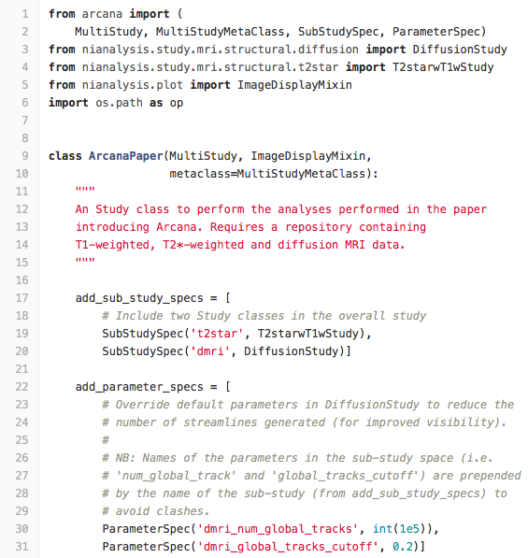

**Figure S.1** - First section of the definition of the *ArcanaPaper* Study class. ArcanaPaper implements the analysis performed for this manuscript. ArcanaPaper is a *MultiStudy* with two sub-studies, a T2*-weighted/T1-weighted multi-study and a dMRI study. Two default parameters of the global tracking pipeline in the dMRI study are overridden to reduce the number of tracks created for visualisation purposes. The class inherits from the *ImageDisplayMixin* class to include methods to display slices of the derived images.

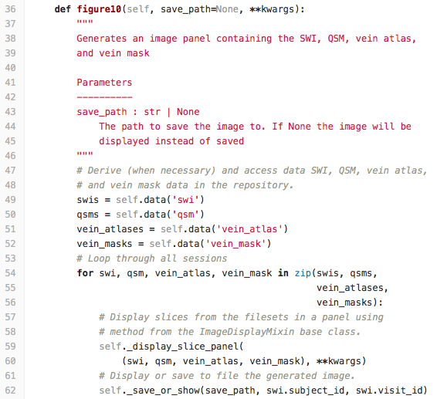**Figure S.2 -** Method in ArcanaPaper class to generate Figure 11 of this manuscript. SWI, QSM and vein mask derivatives are generated on demand if they don’t already exist in the repository by the *data* method. *display_slice_panel* and *save_or_show* methods from the *nianalysis.plot.ImageDisplayMixin* base class are used to display the generated filesets.

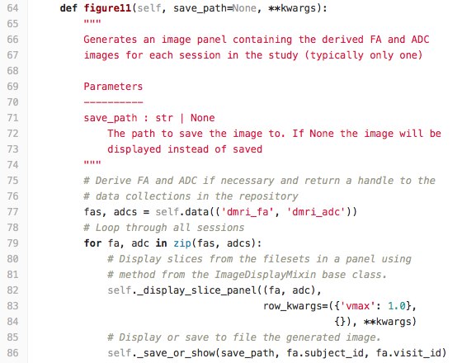

**Figure S.3 -** Method in ArcanaPaper class to generate Figure 12 of this manuscript. FA and ADC derivatives are generated on demand if they don’t already exist in the repository by the *data* method. *display_slice_panel* and *save_or_show* methods from the *nianalysis.plot.ImageDisplayMixin* base class are used to display the generated filesets.

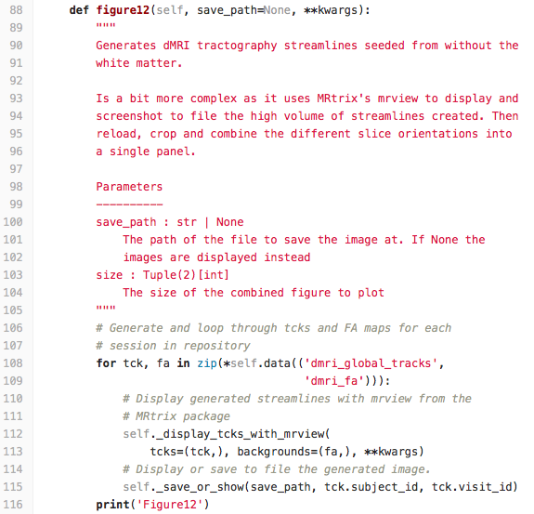

**Figure S.4 -** Method in ArcanaPaper class to generate Figure 13 of this manuscript.Global tracksand FA are derived on demand if they don’t already exist in the repository by the *data* method. Uses the *display_tcks_with_mrview* method in the *nianalysis.plot.ImageDisplayMixin* class to display streamlines on a background of a fractional anisotropy (FA) map using MRtrix’s *mrview* command.

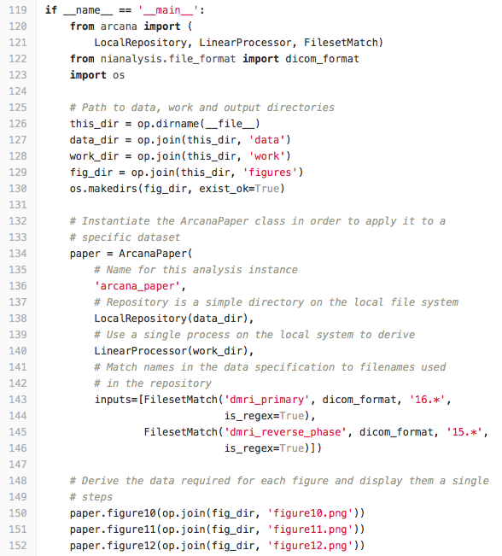

**Figure S.5 -** Instantiation of the specific study class to a dataset stored on the local system. Images for Figures 11, 12 and 13 of this manuscript are generated by eponymous methods of the study. Entries in the study’s data specification are matched to data in the repository using *FilesetSelector* objects. The use of *LinearProcessor* specifies that derivatives are derived using a single process on the local system. Equivalent figures can be generated for alternative datasets by specifying a different repository and inputs.